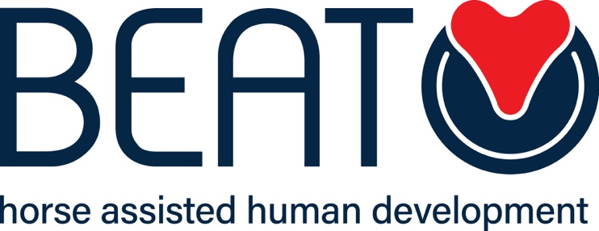

PRIVACY POLICY
Data Protection & Privacy Policy

Name of Organisation: BEAT Limited

Venue Address for which policy applies: All venues Date of last review: 13th March 2023
Date of next review: 13th March 2024
Name of Author: Claire Cole
Any personal data provided by you to BEAT Limited through any means (verbal, written, in electronic form, or by your use of our website) will be held and processed in accordance with the data protection principles set out in the Data Protection (Bailiwick of Guernsey) Law 2017 for the purposes of providing the services you have requested from us, and to meet the legitimate interests of the business.

Introduction

BEAT Limited (the ‘data controller’, referred to below as “us” or “we”) is committed to protecting your privacy. Please read the following in order to learn more about BEAT’s privacy policy and our information collection and use practices.

This policy only applies to data collected by BEAT staff and via our own forms and website. Third party agents, and websites which are linked to ours, are not covered by this policy, please read individual privacy policies detailed below.

If you have any queries concerning your personal information or any questions on our use of the information, please contact us at info@beatgsy.co.uk or send us mail to BEAT Limited, Clifton Cottage, Guernsey, GY3 5DT.

When you request services with BEAT or otherwise provide your personal details to us, you will be asked to consent to our processing of your data under the terms of this policy.

What information do we collect?

- Initial Consultation Form. BEAT ask about your current personal, social, medical and financial circumstances. We may also ask about your background and family history, as well as the issues which are affecting you now. We require this information so that we can decide about our offer of Horse Assisted Human Development to you and to manage the service we provide to you.
- Website - We use Google Analytics to collect anonymous data relating to user behaviour and ‘web traffic’ statistics. The collection and use of this data by Google Inc. is subject to their own Privacy Policies.
- Other Forms - The information you give us on our forms (including all enquiry and application forms) may include your name, postal address, email address, phone number and other messages to us.

What do we use your information for?

We use information held about you in the following ways:

- To provide clients with the professional service requested from us.
- To enable us to offer appropriate opportunities and support to our practitioners.
- To offer suitable Horse Assisted Human Development appointments, and to allocate clients and practitioners.
- To notify you about changes to your appointments and other changes to our services.
- To seek feedback from you on your experience of Horse Assisted Human Development services with us.
- To improve our service to ensure that it is provided in the most effective manner for you and for us.
- To administer our service, including the arrangement of appointments and for financial control, data analysis, research, statistical and survey purposes.
- To keep in touch with those who ask us to, for the purposes of organisational, service and professional development.

What information do we share?

We will not share any information about you with other organisations or people, except in the following situations:

- Consent – BEAT may share your information with professional carers, referrers or others whom you have requested or agreed we should contact.
- Serious harm – BEAT may share your information with the relevant authorities if we have reason to believe that this may prevent serious harm being caused to you or another person.
- Compliance with law – BEAT may share your information where we are required to by law or by the regulations and other rules to which we are subject.

How do we keep your information safe?

All information you provide to us is stored as securely as possible. All paper forms and correspondence are kept in locked filing cabinets. All electronic records are stored on an encrypted computer, all access to which requires password-protected authentication, or by reputable service providers using secure internet ‘cloud’ technology.

Unfortunately, the transmission of information via the internet is never completely secure. Although we will do our best to protect your information using industry-standard protocols and encryption, we cannot guarantee the security of your data transmitted to us via email, including forms completed on our website which are transmitted by email; any transmission is at your own risk. Once we have received your information, we will use strict procedures and security features to try to prevent unauthorised access.

Your identifiable personal information is kept separately from any session notes and other descriptive material. Client notes and other documentation are destroyed 3 years after the end of your programme, and personal contact details are destroyed/deleted after 7 years of no contact or updates.

Your rights

You have the right to ask us to provide a copy of the information held by us in our records, for which we may charge a small fee. You also have the right to require us to correct any inaccuracies in your information. If you would like to do this, please contact us at info@beatgsy.co.uk or send us mail to BEAT Limited, Clifton Cottage, Vale, Guernsey, GY3 5DT.

You may withdraw your consent for us to hold and process your data at any time. However, if you do this while actively receiving Horse Assisted Human Development at BEAT, your Horse Assisted Human Development would have to end. You can withdraw your consent by contacting us at info@beatgsy.co.uk or send us mail to BEAT Limited, Clifton Cottage, Vale, Guernsey, GY3 5DT.

Changes to this policy

We may edit this policy from time to time. If we make any substantial changes we will notify you by posting a prominent announcement on our website.

Resources and Further Reading

The Data Protection (Bailiwick of Guernsey) Law, 2017
Office of the Data Protection Authority
Facebook Privacy Policy Google Privacy Policy
Acuity Scheduling Privacy Policy (Online Appointment booking System)

Paypal Privacy Policy (Online Payment Provider) Wix Privacy Policy (Website Hosting Provider)

BEAT Limited (Company Number (64541) Registered Office: Clifton Lodge, Vale, Guernsey, GY3 5DT

