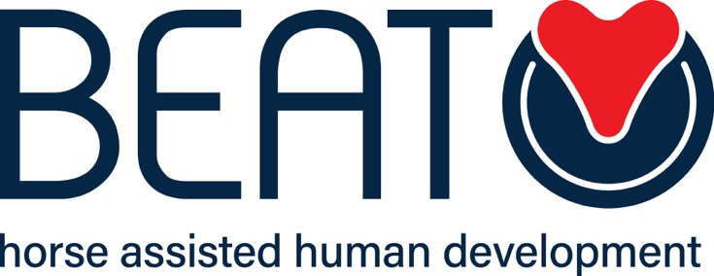

Health and Safety Policy

Name of Organisation: BEAT Limited
Venue Address for which policy applies: All venues Date of last review: 13th March 2023
Date of next review: 13th March 2024
Name of Author: Claire Cole

REMEMBER ! ALWAYS BE AWARE ! EVERYONE CONCERNED SHOULD LEARN HOW TO WORK SAFELY ASK IF YOU DON’T UNDERSTAND AND REPORT ANYTHING THAT SEEMS DAMAGED, UNSAFE, DANGEROUS OR FAULTY

- Directors are asked to note the direct link between Health & Safety and BEAT Limited Insurance arrangements.

- Please note that an “approved BEAT Limited Activity” for the purposes of insurance cover is any BEAT Limited activity which conforms to and complies with these guidelines and which has been approved by BEAT Limited. If in doubt, please refer to BEAT Limited Office.

WHO IS RESPONSIBLE?

  - Directors - are ultimately responsible for everything that goes on in their Group including Health & Safety but we expect clients to listen to instructions carefully and always follow instructions from staff.
  - BEAT Limited Management - are responsible for recruiting instructors, volunteers and helpers. They are responsible for keeping available and/or distributing all relevant papers received from BEAT Limited Office. Up to date information and records are essential.
  - All persons accessing BEAT Limited are responsible for safe working practices.

WHAT ARE THEY RESPONSIBLE FOR?

- VENUE. All aspects of the venue used by BEAT Limited should have been approved by the Directors. A BEAT Limited risk assessment should be completed initially, updated as necessary and checked with copies kept.
- HORSES/PONIES/DONKEYS. Should not be worked with until they have been fully assessed by the managers and passed as of good temperament and suitable for BEAT Limited purposes.
- TACK. All tack and special equipment should be inspected on a regular basis to ensure that it has been maintained, is in good condition and that it fits the equine on which it is being used.
- BEAT Limited STAFF/VOLUNTEERS. All staff and volunteers should be advised on the contents and use of BEAT Limited Health & Safety Guidelines. A programme of training should be discussed and planned appropriate to the volunteers experience and qualifications. All helpers should be given induction training when they first join. They should be capable for all duties they are asked to perform and should be briefed at the beginning of each session.
- All people accessing BEAT Limited should wear comfortable and suitable clothing. It is recommended that jewellery is removed and that long hair should be tied back. Sturdy shoes or boots should be worn

FIRST AID

No BEAT Limited activity may take place without the presence of a person holding an up to date First Aid Certificate. There must be a First Aid Box readily available for each BEAT Limited session.

FIRE DRILL
Everyone working or attending the Group on a regular basis must be instructed on procedures in case of fire. This is to include the location of fire points, use of different types of fire extinguishers, fire alarm method, evacuation plan for both humans and animals, location of master switch, water stop tap and telephone.

ACCIDENT & INCIDENT BOOK
All accidents and incidents must be recorded immediately in the Accident and Incident Book and signed as required. This is an important document and must be retained in Group files even if it has been replaced by a new book. Serious accidents must be reported in accordance with RIDDOR.

GROUP RECORDS & UP-TO-DATE INFORMATION
BEAT Limited should have all up to date information and completed staff/volunteer/client forms available for reference. These will be kept in accordance with Date Protection Guidelines.

BEAT Limited (Company Number (64541) Registered Office: Clifton Cottage, Vale, Guernsey, GY3 5DT

